**ASSIGNMENT2 :**

**DISPLAY HEADER DATA.**

**ON DOUBLE CLICK OF BILLING DOC NO DISPLAY ITEM DATA.**

**ON DOUBLE CLICK OF MATERIAL NO INSIDE ITEM DATA DISPLAY MM03.**

**ON DOUBLE CLICK OF PAYER NO IN HEADER DATA DISPLAY XD03.**

**Main program: ZKIRAN_ASSEMENT3**

|  |
| --- |
| *\*&---------------------------------------------------------------------\** *\*& Report ZKIRAN_TASK11* *\*&---------------------------------------------------------------------\** *\*&* *\*&---------------------------------------------------------------------\** REPORT ZKIRAN_ASSEMENT3.   DATA : it_vbrk TYPE TABLE OF ZKIRAN_VBRk,  wa_vbrk LIKE LINE OF it_vbrk. DATA : it_vbrp TYPE TABLE OF ZKIRAN_vbrp,  wa_vbrp LIKE LINE OF it_vbrp. data v_vbeln TYPE ZKIRAN_VBRk-vbeln.   SELECT-OPTIONS s_vbeln FOR wa_vbrk-vbeln. START-OF-SELECTION. PERFORM getdata.  END-OF-SELECTION. PERFORM display.  *\*&---------------------------------------------------------------------\** *\*& Form getdata* *\*&---------------------------------------------------------------------\** *\*& text* *\*&---------------------------------------------------------------------\** *\*& --> p1 text* *\*& <-- p2 text* *\*&---------------------------------------------------------------------\** FORM getdata . SELECT * FROM ZKIRAN_VBRk INTO TABLE it_vbrk WHERE vbeln IN s_vbeln. ENDFORM. *\*&---------------------------------------------------------------------\** *\*& Form display* *\*&---------------------------------------------------------------------\** *\*& text* *\*&---------------------------------------------------------------------\** *\*& --> p1 text* *\*& <-- p2 text* *\*&---------------------------------------------------------------------\** FORM display . CALL FUNCTION 'REUSE_ALV_GRID_DISPLAY'  EXPORTING *\* I_INTERFACE_CHECK = ' '* *\* I_BYPASSING_BUFFER = ' '* *\* I_BUFFER_ACTIVE = ' '*  I_CALLBACK_PROGRAM = 'ZKIRAN_ASSEMENT3' *\* I_CALLBACK_PF_STATUS_SET = ' '*  I_CALLBACK_USER_COMMAND = 'USER_COMMAND' *\* I_CALLBACK_TOP_OF_PAGE = ' '* *\* I_CALLBACK_HTML_TOP_OF_PAGE = ' '* *\* I_CALLBACK_HTML_END_OF_LIST = ' '*  I_STRUCTURE_NAME = 'ZKIRAN_VBRK' *\* I_BACKGROUND_ID = ' '* *\* I_GRID_TITLE =* *\* I_GRID_SETTINGS =* *\* IS_LAYOUT =* *\* IT_FIELDCAT =* *\* IT_EXCLUDING =* *\* IT_SPECIAL_GROUPS =* *\* IT_SORT =* *\* IT_FILTER =* *\* IS_SEL_HIDE =* *\* I_DEFAULT = 'X'* *\* I_SAVE = ' '* *\* IS_VARIANT =* *\* IT_EVENTS =* *\* IT_EVENT_EXIT =* *\* IS_PRINT =* *\* IS_REPREP_ID =* *\* I_SCREEN_START_COLUMN = 0* *\* I_SCREEN_START_LINE = 0* *\* I_SCREEN_END_COLUMN = 0* *\* I_SCREEN_END_LINE = 0* *\* I_HTML_HEIGHT_TOP = 0* *\* I_HTML_HEIGHT_END = 0* *\* IT_ALV_GRAPHICS =* *\* IT_HYPERLINK =* *\* IT_ADD_FIELDCAT =* *\* IT_EXCEPT_QINFO =* *\* IR_SALV_FULLSCREEN_ADAPTER =* *\* O_PREVIOUS_SRAL_HANDLER =* *\* IMPORTING* *\* E_EXIT_CAUSED_BY_CALLER =* *\* ES_EXIT_CAUSED_BY_USER =*  TABLES  t_outtab = it_vbrk  EXCEPTIONS  PROGRAM_ERROR = 1  OTHERS = 2  . IF sy-subrc <> 0. *\* Implement suitable error handling here* ENDIF.   ENDFORM. FORM USER_COMMAND USING r_ucomm TYPE sy-ucomm  rs_selfield type slis_selfield.  IF r_ucomm eq '&IC1' and rs_selfield-FIELDNAME eq 'VBELN'.  DATA v_vbeln TYPE vbeln. v_vbeln = rs_selfield-value.  CALL FUNCTION 'CONVERSION_EXIT_ALPHA_INPUT'  EXPORTING  input = v_vbeln  IMPORTING  OUTPUT = v_vbeln  .    SELECT * from ZKIRAN_VBRP INTO TABLE it_vbrp WHERE vbeln = v_vbeln.  CALL FUNCTION 'REUSE_ALV_GRID_DISPLAY'  EXPORTING  I_CALLBACK_PROGRAM = 'ZKIRAN_ASSEMENT3'  I_CALLBACK_USER_COMMAND = 'USER_COMMANDE'  I_STRUCTURE_NAME = 'ZKIRAN_VBRP'  TABLES  t_outtab = it_vbrp  EXCEPTIONS  PROGRAM_ERROR = 1  OTHERS = 2  .  IF sy-subrc <> 0. *\* Implement suitable error handling here*  ENDIF.  ELSEIF r_ucomm eq '&IC1' and rs_selfield-FIELDNAME eq 'KUNRG'.  set PARAMETER ID 'KUN' FIELD rs_selfield-value.  CALL TRANSACTION 'XD03'.  ENDIF. ENDFORM. FORM USER_COMMANDE USING r_ucomm TYPE sy-ucomm  rs_selfield type slis_selfield.  IF r_ucomm eq '&IC1' and rs_selfield-FIELDNAME eq 'MATNR'.   set PARAMETER ID 'MAT' FIELD rs_selfield-value.  CALL TRANSACTION 'MM03'.  ENDIF. ENDFORM. |

**INPUT SCREEN :**

Given range from 1000 to 1003 exclude 1002

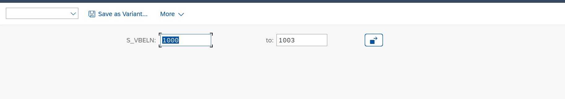

**OUTPUT SCREEN 1:**

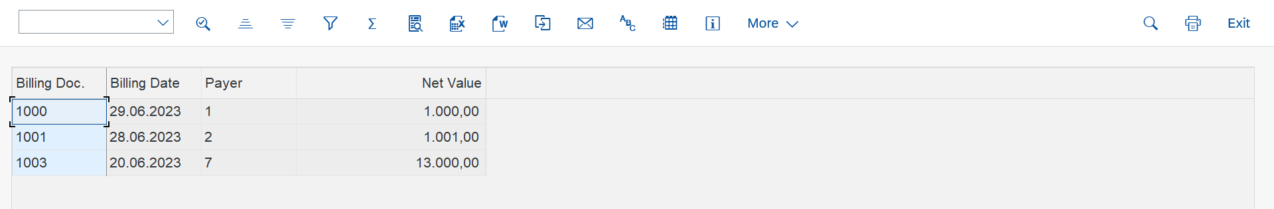

**DOUBLE CLICK ON BILLING DOC:**

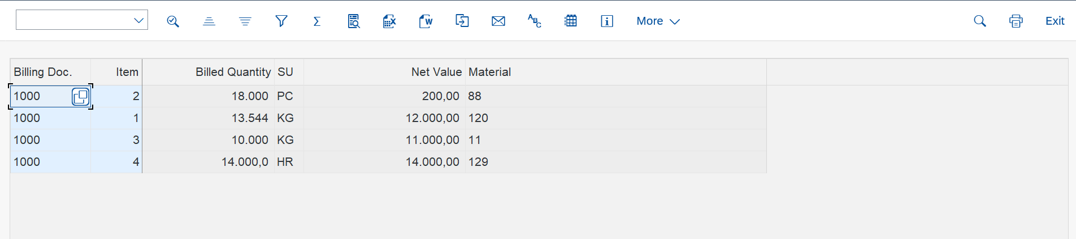

**DOUBLE CLICK ON MATERIAL:**

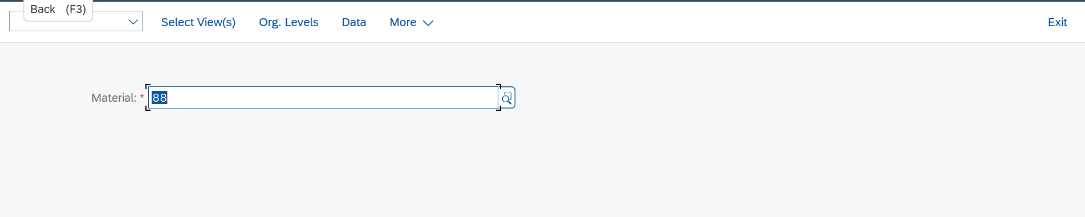

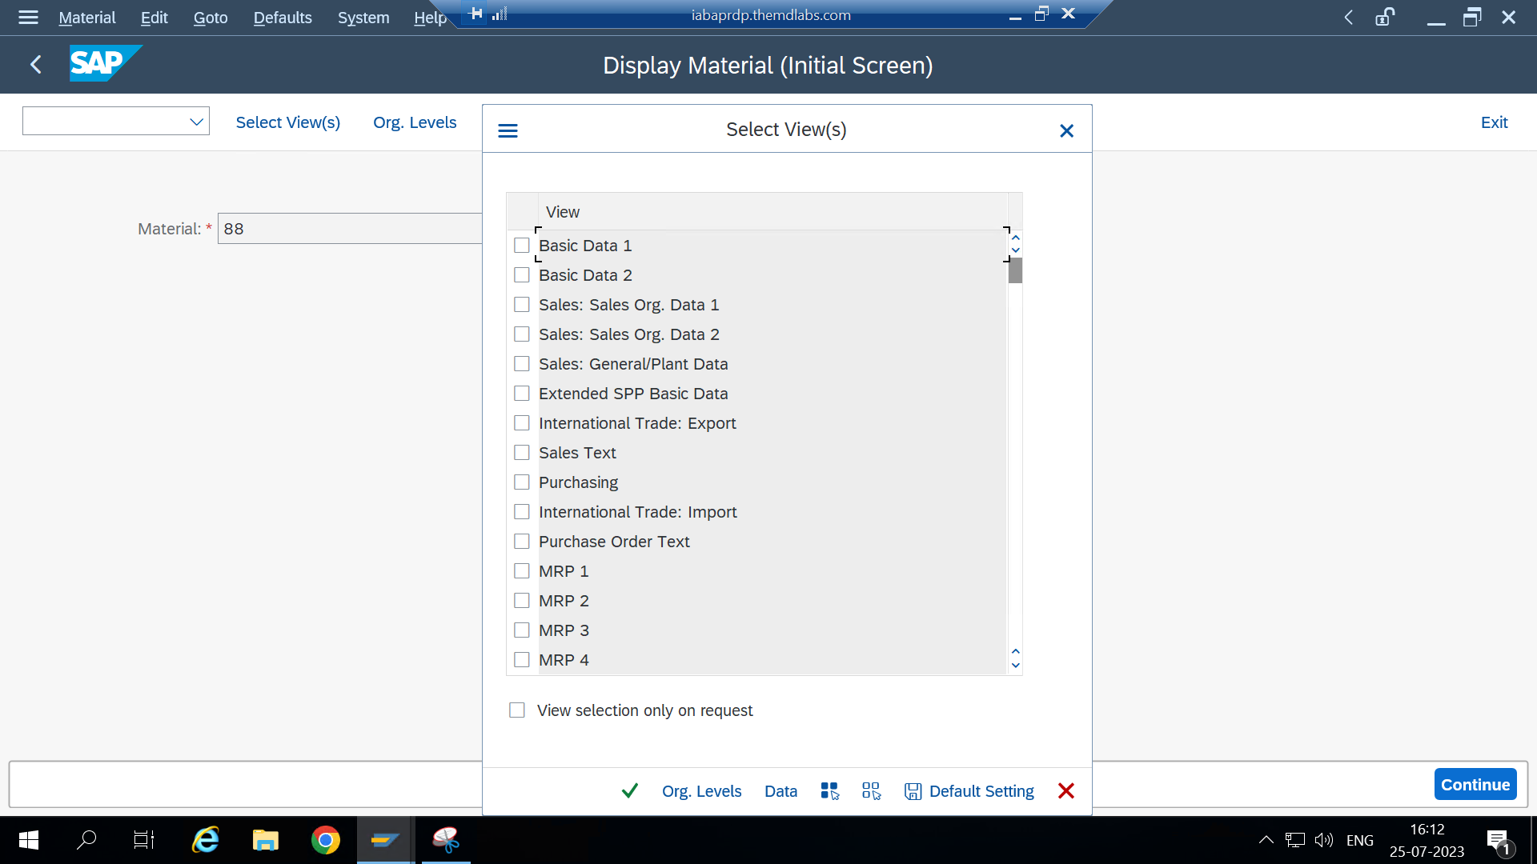

**DOUBLE CLICK ON PAYER:**

**OUTPUT SCREEN:**

